***Motors and Belts [4.0]***

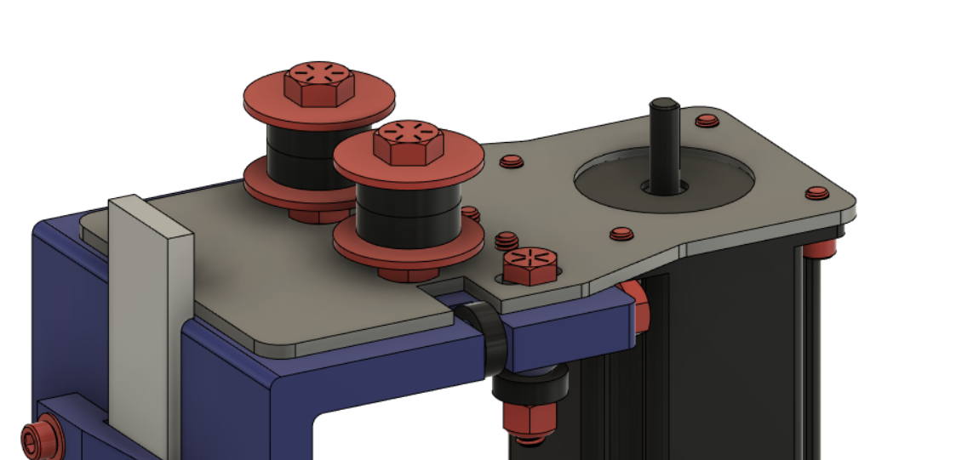

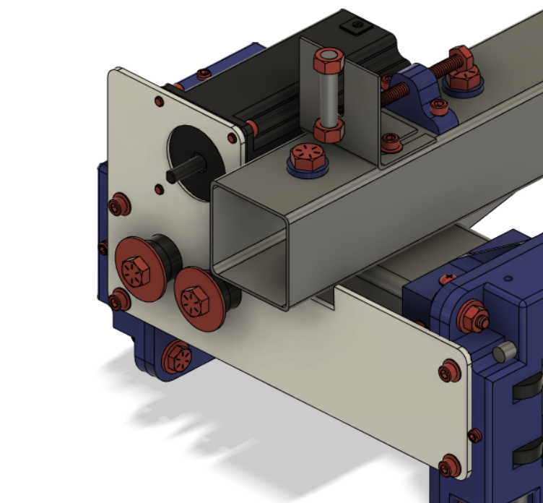

***X Motors and Belts [4.1]***

**Parts Needed**

**1x X-Axis Assembly**

**1x Small Stepper Motor**

**4x #10-32 - 3/8” Screw**

**4x 608zz Bearing Washers (3D Printed)**

**2x 5/16” Nuts**

**4x 5/16” Fender Washers**

**4x 608ZZ Bearings**

**2x 5/16 - 1.5” Bolts**

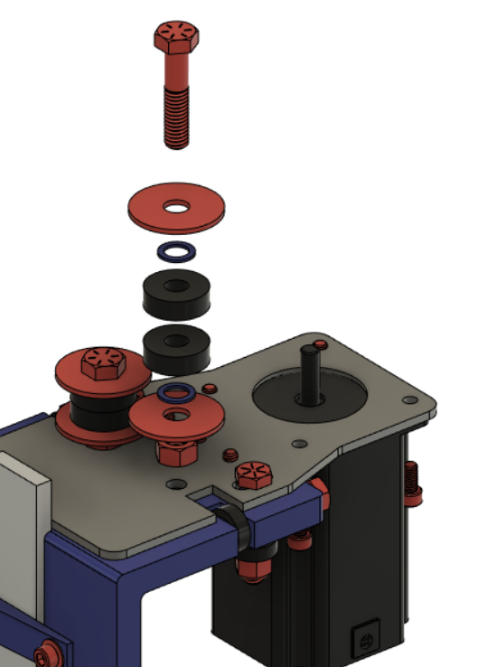

***Y Motors and Belts [4.2]***

**Parts Needed**

**1x Completed Gantry**

**1x Large Stepper Motor**

**4x 608zz Bearing Washers (3D Printed)**

**4x #10-32 - 5/8” Screws**

**4x #10-32 - 3/8” Screws**

**4x #10 Washers**

**4x 608zz Bearings**

**2x 5/16” - 1” Bolts**

**2x 5/16” Nuts**

**2x 5/16” Fender Washers**

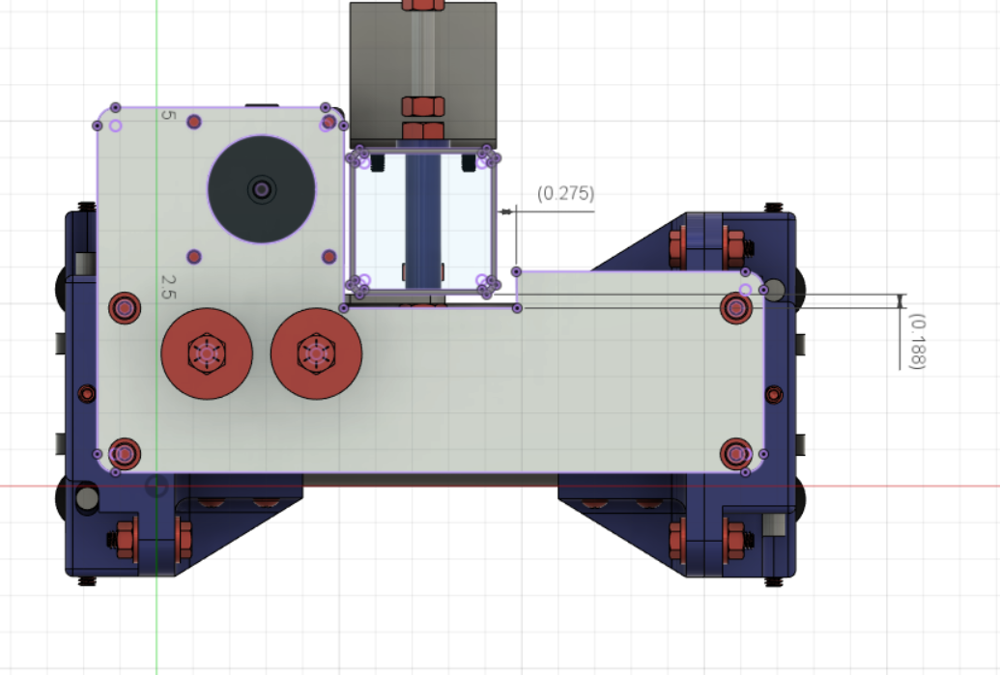

Holes for mounting the motor plate are not already in the bearing blocks. Use this reference to position to properly align the Y-Motor plate so you can drill and tap the mounting holes in the bearing blocks. Drill and tap for #10-32 screws.

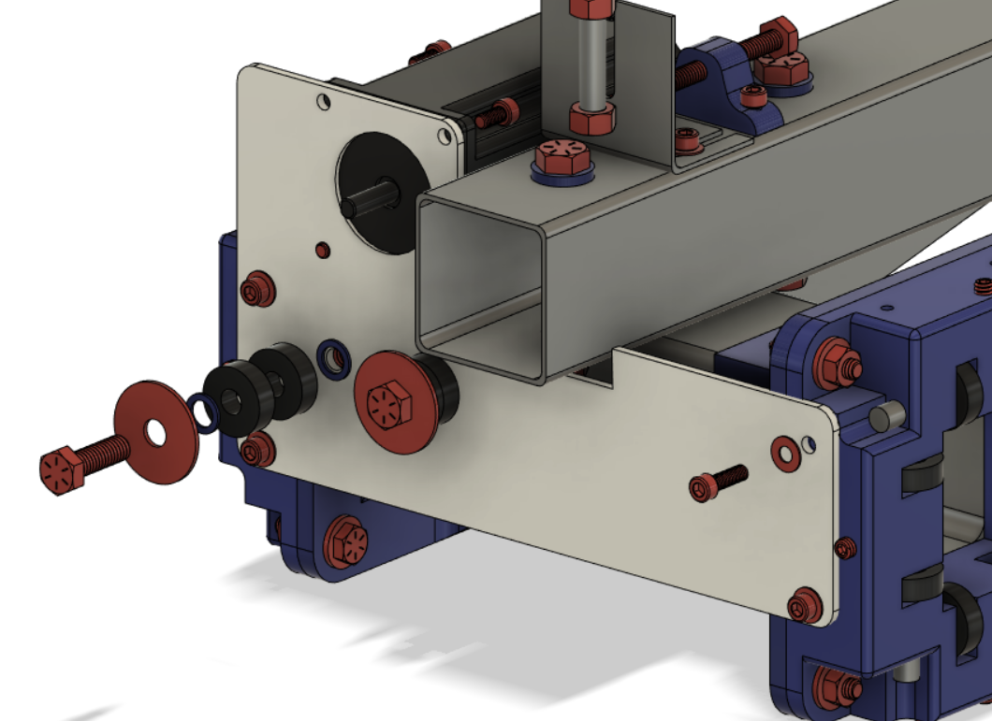

Longer #10 Screws are used for mounting the Y-Motor Plate. Shorter screws are used for mounting the motor.

**Pro Tip:** There are 2 5/16” nuts on the backside of the motor plate that hold on the belt rollers.